**See, beloved, God demands repentance. He demands realization of ______.**

**We mourn in spiritual poverty over our sin when we come into the kingdom, and we continue to do it all our life long.**

**Just because Paul knew where the victory was, didn’t mean it was once for all. Paul fought this every day of his life until he met Jesus face to face. It’s a way of life to deal with sin. It never changes.**

**You get saved by being bankrupt in your spirit and mourning over your sin, and that’s the way it ought to be for the rest of your life.**

**Well…are you mourning today?**

**Other scriptures cited: Ezek. 21:9; Isa. 22:12, 13, 14; Prov. 2:14; 2 Thess. 2:12; Prov. 17:22; 2 Cor. 12:21, 2:7; Ps. 51:17; Rom. 7:15, 17, 18, 20, 21-23, 24, 25, 8:23; Phil. 1:22-23; 2 Cor. 5:2**

**If you have a counseling need or just wish to speak with the pastor, please feel free to call at any time. Contact the Church @ 520-586-2337, Pastor’s cell phone is 575-799-6149 or his email:** **nlteachpreach@gmail.com**

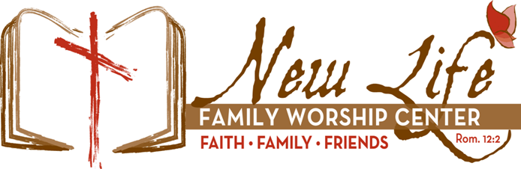“Be transformed by the renewing of your mind that you may prove what that good acceptable and perfect will of God is.” Romans 12:2

The goal of our instruction is love from a pure heart and the promotion of His truth.

642 E Pomerene Road, Benson Az 85602

PO Box 42, Pomerene Az 85627

Fellowship of Worship

19 January 2025

**The sermon on the mount**

**Lesson 11**

**“Happy are the Sad”**

**Matthew 5:4-12**

**Elders**

**Steve Medeiros Mike Cox Roger Choate**

**Ron Graves Tom Van Wart John Peralta**

**Our lessons can be heard for your convenience on our website www.newlifebenson.com, through our app which is available to download via our website and are also available for viewing via YouTube.**

**Lord’s Day: 9:00 AM - Bible Study [to include children’s classes]**

**Sister Renee Cox – “Jonah”**

**Brother Bob Medeiros – “For I Am With You-Do Not Fear”**

**10:30 AM - “Fellowship of Worship”**

**Elder Medeiros – Gospel of Matthew, “Sermon on the Mount”**

**6:30 PM – “Family Bible Hour” - Elder Medeiros - James**

**Tuesday**

**10 AM - Prayer Meeting**

**12:00 PM & 5:00 PM – AA Meetings**

**Wednesday**

**10:00 AM Women’s Interdenominational Bible Study**

**5:30 PM – New Life Kids**

**New Life Students - Elder John Peralta**

**6:30 PM 1 John - Elder Medeiros**

**Friday:**

**12:00 PM - AA Meeting**

**Events This Week**

**NLOT (New Life Outreach Team)-Mon., Jan. 20th at 10:00AM**

**Wed., Jan. 22nd at 10:00AM**

**New Life Kids’ Theme Night-Neon Night-Wed., Jan. 22nd at 5:30PM** **New Life Women’s Fellowship-Sat., Jan. 25th at 10AM-12PM at Jennifer Lundberg’s home.**

**\*\*Sign up for this & other events in the foyer!**

**Order of Service:**

**Welcome/Opening prayer – Elder Ron Graves**

**Call to Worship!**

**Music**

**Message**

**A Call to Follow Christ**

**Closing Prayer – Elder Tom Van Wart**

**Departing Song**

**New Life Family Worship Center’s Vision and Mission Statements:**

**New Life Family Worship Center desires to be a thoroughly biblical church that seeks God’s presence and leadership. To that end, we are committed to proclaiming God’s perfect law and His glorious gospel of grace in Jesus Christ throughout the world, and to “…contend earnestly for the faith which was once delivered to the saints” (Jude 3). “Therefore, whether you eat or drink, or whatever you do, do all to the glory of God.” (1 Cor. 10:31).**

**In response to God’s grace and love toward us, the mission of this congregation is to glorify the God of the Scriptures by promoting His worship, sharing His Word evangelistically, belonging to a God-centered fellowship which encourages us to grow spiritually while serving Him, and acting with love and compassion toward those in need. (Matt. 22:37-40; 28:16-20).**

**See the problem I have now is I know too much to be too happy.**

**God is ready to strike an eternal judgment. What are we laughing about?**

**The church today has a ____________ sense of sin.**

**Conviction of sin must precede conversion and then it _______ ___________ ____. That’s the pathway of blessedness.**

**Salvation comes by repentance and comes by mourning, and God demands that.**

**The New Testament never talks about people making a decision, never talks about walking an aisle, never talks about signing a card, never talks about having a counselor tell you - “you’re a Christian.” All it talks about is if you are a Christian, there will be evidence of that present in your life. That’s always the real issue.**