Rich people put their money and their fortune into _____________.  James’ point is so basic. If you’ve lived your life this way, then the question is whether you worship God at all.  I don’t want you to be irresponsible about your life; but I want you to know that you can’t hoard it.  Hoarded wealth is a witness for the _____________ declaring one’s guilt.  The rust which, first of all, was the ____________ element, then personalized becomes the __________, and then personalized becomes the ______________.  And this is a reminder that hell is a physical place.  How utterly unthinkable, amassing wealth in a day when the world is perishing.  God gives us new things every day.  Other scripture in order of citation: Luke 16:19, 23, 6:24-25; Acts 8; 1 Tim. 5; Luke 6:38; 1 Cor. 16:2; Luke 16:9; 1 John 3; Gal. 2:10; 1 Tim. 5:18; Luke 10:7, 12:18-19; Matt. 6:20; John 5:29  If you have a counseling need or just wish to speak with pastor, please feel free to call at any time. Contact the Church @ 520-586-2337, Pastor’s cell phone is 575-799-6149 or his email: nlteachpreach@gmail.com | 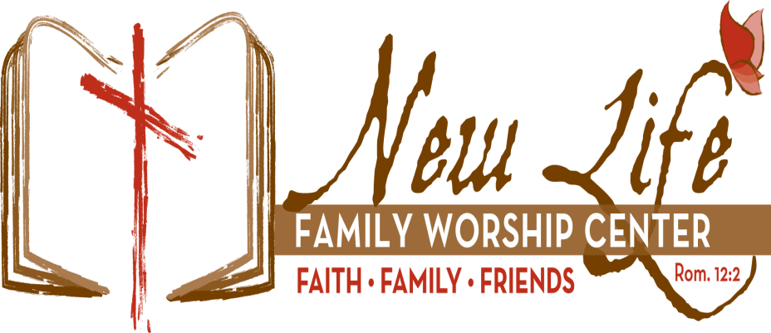  … “Be transformed by the renewing of your mind that you may prove what that good acceptable and perfect will of God is.”  Romans 12:2  642 E Pomerene Road, Benson Az 85602  PO Box 42, Pomerene Az 85627  Sunday 26 January 2025  The goal of our instruction is love from a pure heart and the promotion of His truth.  A warm welcome to you if you are a first-time visitor to New Life Family Worship Center; we are glad you decided to worship with us today. If this is your regular place of worship, we are glad you are here once again. May you be blessed by His Holy Word today.  James - Lesson 68  “The Wicked Rich”  James 5:1-3  Elders  Steve Medeiros Mike Cox Roger Choate Ron Graves Tom Van Wart John Peralta
New Life Family Worship Center’s Vision and Mission Statements:  New Life Family Worship Center desires to be a thoroughly biblical church that seeks God’s presence and leadership. To that end, we are committed to proclaiming God’s perfect law and His glorious gospel of grace in Jesus Christ throughout the world, and to “…contend earnestly for the faith which was once delivered to the saints” (Jude 3). “Therefore, whether you eat or drink, or whatever you do, do all to the glory of God.” (1 Cor. 10:31).  In response to God’s grace and love toward us, the mission of this congregation is to glorify the God of the Scriptures by promoting His worship, sharing His Word evangelistically, belonging to a God-centered fellowship which encourages us to grow spiritually while serving Him, and acting with love and compassion toward those in need (Matt. 22:37-40; 28:16-20).  Lord’s Day:  9:00 AM: “Bible Study” [to include children’s classes]  Sister Renee Cox - “Jonah”  Brother Bob Medeiros – “For I Am with You-Do Not Fear”  10:30 AM: “A Fellowship of Worship”  Elder Medeiros – Gospel of Matthew, “Sermon on the Mount”  Children’s Church during service  6:30 PM: “Family Bible Hour”  Elder Medeiros, “James”  Tuesday:  10 AM: Revival Prayer Meeting  12:00 PM & 5:00 PM – AA Meetings  Wednesday:  10:00 AM Women’s Interdenominational Bible Study  5:30 PM – New Life Kids  New Life Students - Elder John Peralta  6:30 PM: Elder Medeiros – “1 John”  Friday:  12:00 PM - AA Meeting | Our lessons can be heard for your convenience on our website at www.newlifebenson.com, through our app which is available to download via our website, and are also available for viewing via YouTube.  James is condemning these wicked rich people personally as he uses the word “_____” twice on that verse.  Four characteristics of the wicked wealthy that result in their judgment:  #1 - it is not used to provide for our ____________.  #2 - it is not devoted to His service. [____________]  #3 - it is not used to _____ the _______.  #4 – it is not used to ______ for the __________.  And we could add another: it is not used to support people who _____________.  There’s no place for saying you’re a believer, you’re a true child of God, you’re a lover of Christ, a servant of God, and then amassing a fortune, uselessly stashed away without regard for God’s Word at all.  The word riches generally refers to food – grain, wheat, barley, perhaps even some meat that would be stored.  Your hoarding is so useless, because in the end it’s going to be no good to anybody.

